VIRTUAL GATE LOCATIONS
December 2024
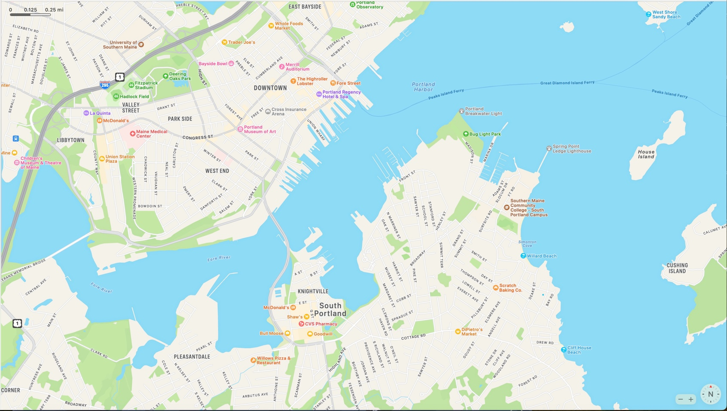
South Gate
Water Gate
North Gate

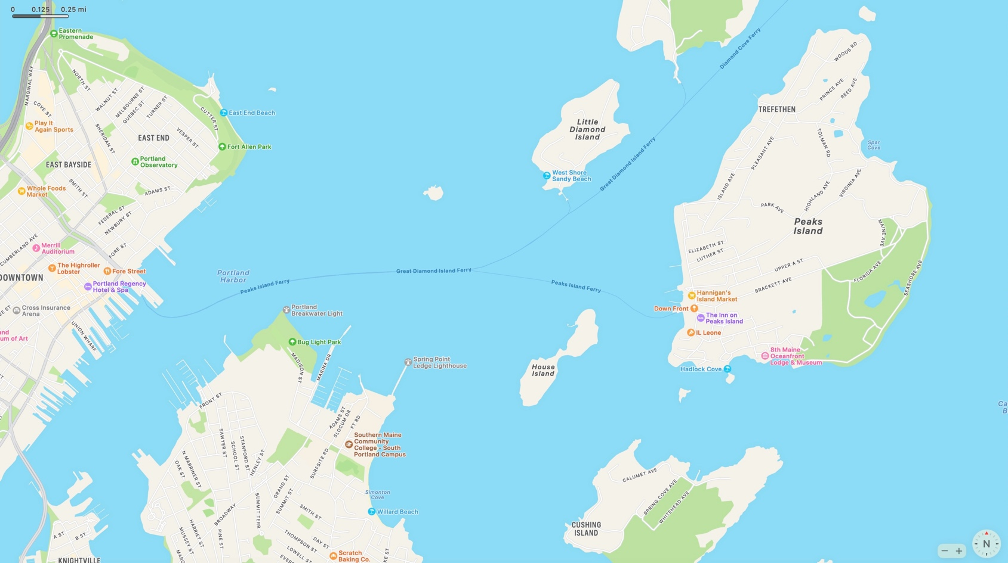
Peaks Gate

